1. 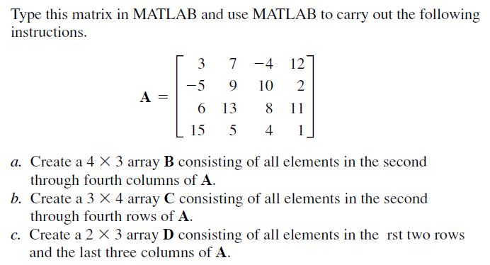

d. Please set the low bound of the matrix A to be 0. Hint: use the command ‘find’ to find the address of the matrix elements less than zero.

1. A company must purchase five kinds of material. The following table gives the price the company pays per ton for each material, along with the number of tons purchased in the months of May, June, and July:

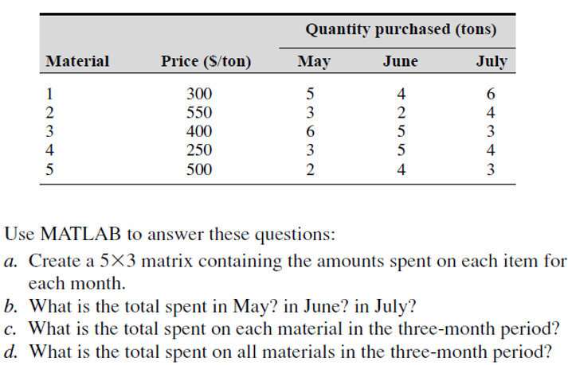



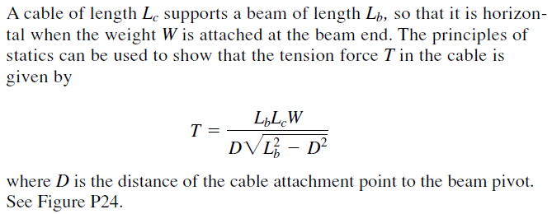

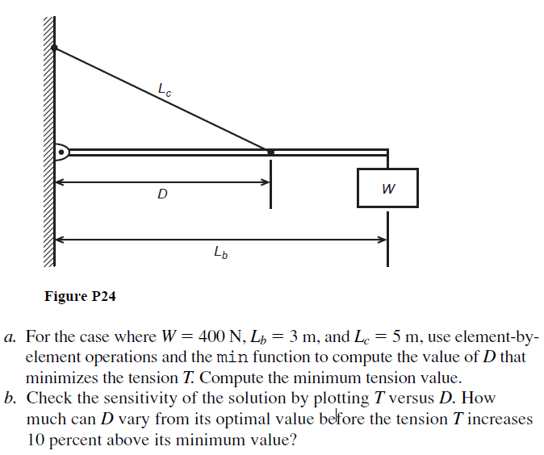

1. The following equation is a special case of one model used to describe the blood pressure in the aorta during systole (the period following the closure of the heart’s aortic valve). The variable *t* represents time in seconds, and the dimensionless variable *y* represents the pressure difference across the aortic valve, normalized by a constant reference pressure.

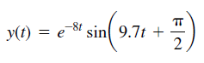

Plot this function for *t>* 0.



